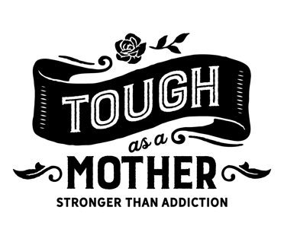
[INSERT PARTNER LOGO]
Media Contact:
[INSERT NAME]
[INSERT ORG NAME]
[INSERT PHONE # / INSERT EMAIL]

NEW STATEWIDE PUBLIC AWARENESS CAMPAIGN CONNECTS
COLORADO MOTHERS TO SUBSTANCE USE DISORDER TREATMENT SERVICES
“Tough as a Mother” initiative aims to break the stigma around mothers seeking addiction support

[INSERT DATE –– INSERT LOCATION, Colo.]: “Tough as a Mother,” is a collaborative statewide initiative between the Colorado Office of Behavioral Health, and the state’s managed services organizations: Signal Behavioral Health Network, AspenPointe, Mental Health Partners and West Slope Casa, as well as other community partners across the state. [ENTER ORG NAME], is connecting Colorado mothers with dependent children to substance use disorder treatment services in their communities. It launched in early May to coincide with Mother’s Day.

Nationally, more than 19.5 million women use illicit drugs each year, and more than 8.4 million misuse prescription drugs. [INSERT LOCAL STAT ABOUT PREVALENCE IN COMMUNITY]. Although there are efforts in Colorado and across the country to engage pregnant women in substance use disorder treatment, little outreach that has been done to mothers with dependent children who are struggling with alcohol and other drugs. Because of societal stigma and perceptions about mothers with addiction, this is a priority population that has been difficult to reach and is reluctant to seek treatment.

“Tough as a Mother” seeks to break that stigma by acknowledging that substance use disorder is a medical condition, not a moral shortcoming, and those who suffer are worthy and deserving of support and treatment. The campaign aims to empower women to prioritize their mental, emotional and physical health and relies on a mix of outreach strategies, including partner engagement, community outreach, and traditional and digital media marketing and advertising.

[INSERT PROVIDER QUOTE]

[ENTER ORG NAME] is supporting the “Tough as a Mother” campaign by [INSERT outreach efforts happening in your community].

To learn more about the “Tough as a Mother” campaign, including how to access outreach materials and get involved in outreach efforts, visit www.toughasamother.org.

––End––

ABOUT TOUGH AS A MOTHER
Tough as a Mother is a statewide public awareness campaign, launching in May 2020, to help connect Colorado mothers with dependent children to substance use treatment providers in their communities. It’s a collaborative statewide initiative between the Colorado Office of Behavioral Health, and the managed services organizations: Signal Behavioral Health Network, AspenPointe, Mental Health Partners and West Slope Casa. For more information, visit www.toughasamother.org.

ABOUT [INSERT ORG NAME]
[INSERT ORG BOILERPLATE]

